ARCHITECT REVIEW
SALDEV-1413 | Stepped-up Pricing ARR Flows
Flywire Partial sandbox | Read-only implementation and promotion-readiness assessment
Environment | FlywirePartial | Org 00DhG0000000jOX | Sandbox
Review date | 26 August 2026
Evidence | Active-state read-back | retrieved metadata | Apex test | SOQL collision checks
Decision | Changes Requested - not ready for promotion
Boundary | No code edits, deployment, activation, data changes, or Production changes

ARCHITECT DECISION
Do not promote yet. The implementation is bulk-aware and metadata-driven, but its aggregation key merges distinct lines, seven active flows conflict with the latest story clarification, and rollup failures can leave unsafe prorate divisors.

Acceptance outcome
# | Scope | Result | Evidence
1 | Aggregation correctness | Fail | Apex groups only by Quote + Product; sandbox evidence found 20+ groups with multiple distinct line identities.
2 | Requirement alignment | Fail | The final story comment says retain Quoted Usage fields, but two mappings and seven active flows average them.
3 | Runtime durability | Fail | Partial SaveResults are ignored and three flows divide directly by Total_Prorate_Multiplier__c.
4 | Active component scope | Pass | All 12 named target flows are active/latest; the active B2B XB API name is the _1 definition.
5 | Automated proof | Partial | Focused Apex tests passed, but handler coverage is 72% and four mappings plus Flow behavior are untested.

Correction and control path
Use a targeted correction: preserve the metadata-driven rollup engine, group by a stable ramp-line identity, align the seven affected flows with the final product-owner decision, make rollup writes atomic, and prove the result with focused Apex and business UAT.
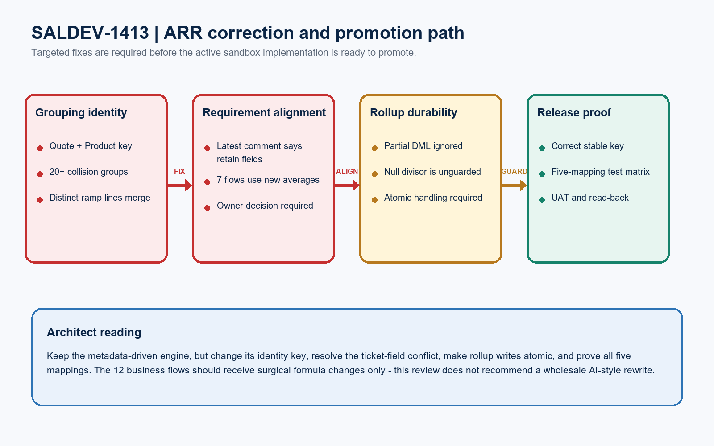
Figure 1. SALDEV-1413 ARR correction and promotion path
DESIGN READING
Red marks release blockers. Amber marks runtime risk. Green is the required promotion proof. Correct the shared engine and formulas surgically; do not rewrite all 12 flows.

Current SALDEV-1413 implementation evidence

Apex and configuration evidence
Evidence area | Current implementation | Acceptance | Architect reading
Group identity | Quote + Product | Fail | Distinct ramp lines can merge.
Requirement mapping | 5 CMDT mappings | Fail | Two usage mappings contradict the final comment.
DML handling | update(..., false) | Fail | Partial SaveResults are unchecked.
Prorate safety | Direct division | Fail | Three flows lack divisor guards.
Audit narrative | Healthcare text mismatch | Fail | Formula and audit text use different fields.
Bulk structure | 2 queries + 1 DML | Pass | The bulk execution pattern is sound.

Flow and test evidence
Evidence area | Observed state | Acceptance | Architect reading
Usage-field flows | 7 active flows | Fail | Seven flows change fields marked to retain.
Prorate flows | 3 active flows | Fail | Three flows divide without a guard.
Collision evidence | 20+ groups | Fail | 395 lines / 394 identities in one group.
Test coverage | 5 methods; 72% | Fail | Only the rate mapping is asserted.
Definition state | 12/12 active/latest | Pass | All target definitions match.

PROMOTION BLOCKER
Do not promote until duplicate-line grouping, usage-field alignment, divisor safety, and all five mappings are proven.

Implementation and release boundary
Component type | Focused scope | Required action
Apex rollup service | calculateAveragePrice (QuoteLineTriggerHandler) | Group by Opportunity_Line_Id__c or an approved composite identity.
Quote Line trigger | QuoteLineTrigger after-save path | Preserve bulk execution; make recursion reset and error handling deterministic.
Custom metadata | 5 Quote Line rollup mappings | Validate fields and operations; retain/remove usage mappings after owner decision.
Usage ARR flows | 7 active flows | Apply only the approved usage-field formula decision; preserve unrelated logic.
Prorate ARR flows | Edu Payables; Fixed Price; Travel Payables | Guard null/zero totals and require atomic rollup completion.
Automated tests | Apex plus targeted Flow/UAT scenarios | Cover five mappings, duplicate identities, bulk quotes, delete/update, null/zero, and regression.

Release sequence
Phase | Required evidence
Pre-deployment | Obtain written owner confirmation on Quoted Usage fields; approve the stable line identity; retrieve the current target-org baseline.
Sandbox correction | Make a focused Apex/mapping/formula change only; preserve unrelated Flow behavior and active-state boundaries.
Validation and UAT | Run the expanded Apex matrix, focused Flow tests, check-only validation, stepped/non-stepped business scenarios, and capture job IDs and record-level expected ARR.
Promotion and read-back | Promote only after approval; verify active versions, Apex coverage, rollup fields, ARR outputs, and logs. Roll back the approved package if a critical regression appears.

PRODUCTION GATE
This review covered FlywirePartial only. Production was not inventoried or changed. Re-retrieve current Production metadata and run focused check-only validation before any deployment decision.

UAT and approval gates
Test | Pass evidence
Stepped grouping | Two occurrences of the same product retain separate identities while each ramp sequence receives its own average and total proration.
Non-stepped regression | A non-stepped line produces the same ARR as the current approved baseline with no average-field side effect.
Usage-field decision | Percent and amount scenarios match the written product-owner decision, including the existing divide-by-100 behavior.
Prorate products | Edu Payables, Fixed Price, and Travel Payables handle populated, null, and zero total-prorate conditions without blank ARR or Flow faults.
Bulk and lifecycle | Multi-quote insert, update, delete, start-date shift, and duplicate-product tests pass with expected rollup placement.

Required approval gates
# | Required action | Owner | Evidence needed
1 | Confirm usage-field requirement | Product Owner / Architect | Written decision resolving the final comment versus earlier design text.
2 | Approve rollup identity | CPQ Architect | Named stable key and examples for repeated products, bundles, and ramp groups.
3 | Complete focused correction | Development Lead | Reviewed Apex, CMDT, and Flow diff with no unrelated rewrite.
4 | Validate sandbox package | Release Manager / QA | Expanded test results, coverage, check-only job ID, UAT records, and expected values.
5 | Promote and read back | DevOps / Business Owner | Deployment receipt, active-version checks, field-level read-back, ARR results, and sign-offs.

Ready-to-paste architect response
STORY COMMENT
Architect review completed for SALDEV-1413 in FlywirePartial. Changes Requested. All 12 target flows are active/latest and focused Apex tests passed, but Quote + Product grouping can merge distinct line identities. The final story comment says retain Quoted Usage Percent and Amount; two mappings and seven active flows average them. Partial rollup failures are ignored, and three flows divide by Total_Prorate_Multiplier__c without a null/zero guard. Confirm the usage-field requirement, approve a stable line key, make writes atomic, protect the divisor, and run the five-mapping stepped/non-stepped matrix before promotion. Retrieval 09ShG000006FuUgUAK; Apex 707hG00000LJDjlQAH. No code, metadata, activation, deployment, data, or Production changes were made.

